Report on Activity I

- Review the floor plan and IL outcome assigned to your group.

- As a group, create a learning activity that will achieve the assigned outcome within the assigned space. The setting (e.g. class level, subject, time) is up to you; try to use a setting with a class level, subject, or time component common to your group.

- Individually, write a quick summary of your group’s learning activity and any important things the group had to consider due to the assigned space. Each member of the current group will be responsible for reporting on your space and learning activity to a new group after the break.

- Before you leave, take a copy of your group’s floor plan and a color sample from the paint can on your table. Be sure to bring these back with you after the break.

Purple Table

Standard 2, Performance Indicator 2.

Outcome:
- Constructs a search strategy using appropriate commands for the information retrieval system selected (e.g., Boolean operators, truncation, and proximity for search engines; internal organizers such as indexes for books).

Floor Plan

Assumptions: Course-integrated instruction for a lower division Writing class, such as 1st-semester English. 80 minutes.

The space available for this session has obstructed sight lines for students sitting at the sides of the room and trying to see the projection screen. To mitigate this problem, group work will take up the bulk of the session time so that students aren't expected to focus their attention at the front of the room. Three groups will form and each will have a different task to complete and share with the rest of the class.

Group 1: Boolean. Students will receive written directions that one student will read to the group. These directions will guide the students through kinesthetic demonstrations of Boolean Operators. For example, all the students wearing jeans or cargo pants will stand, next all the students wearing jeans or cargo pants and not watches will stay standing and the others will sit back down. Students will then select commands or create new ones that they feel demonstrate the effects of Boolean Operators to teach the concept to the class.

Group 2: Indexes and Synonyms. Students will receive written directions to guide them through analyzing internal organizers (e.g., book indexes) to enhance their ability to identify synonyms and broader and narrower terms for their search topics. They will also brainstorm additional terms based on their own knowledge of the subject. Students will be encouraged to consider the importance of having more than one way to describe a topic when they are looking for resources, since different writers may use different terms.

Group 3: Defining the Question. Students will receive written directions to guide them through an exercise to practice organizing search terms in order to develop a narrowly defined topic appropriate for a college essay. They will be introduced to techniques of mind mapping and outlining as part of a process of grouping ideas in preparation for developing search strategies.

After 10-12 minutes, students will present what they've learned to the rest of the class. Guided by the instructor, students will then use these ideas to put together some effective search strings that the instructor will write on large sheets of paper. The instructor will introduce the syntax of search strings. Some of the searches will be demonstrated in the electronic databases using the instructor's station and the projector. Students will be asked to move their chairs out of the corners of the room so that they can see during the demonstration.

~ Facilitator: April Cunningham, Palomar Community College

Orange Table

Standard 2, Performance Indicator 5

Outcomes:
- Differentiates between the types of sources cited and understands the elements and correct syntax of a citation for a wide range of resources.
- Records all pertinent citation information for future reference.

Floor Plan

Our group felt that we would assume the following about Standard 2 Performance Indicator 5 Assumption -- English class, FYE Outcomes Differentiate between the types of sources cited and understands the elements and correct syntax of a citation for a wide range of resources Records all pertinent citation information for future reference

With classroom control software, ceiling mounted projector, and interactive smartboards we still wanted to bring in physical examples of different item so students would create applicable and correct citations -- split up the class with items (electronic and print versions) and discuss how citation would differ (MLA format) if the item was found electronically versus print.
Also if it was a book vs. article vs. website...etc.

Reporting back -- with students modeling citation using smartboard or instructor station.

~ Facilitator: Lynn Lampert, California State University - Northridge

Green Table

Standard 2, Performance Indicator 2.

Outcome:
- Constructs a search strategy using appropriate commands for the information retrieval system selected (e.g., Boolean operators, truncation, and proximity for search engines; internal organizers such as indexes for books).

Floor Plan

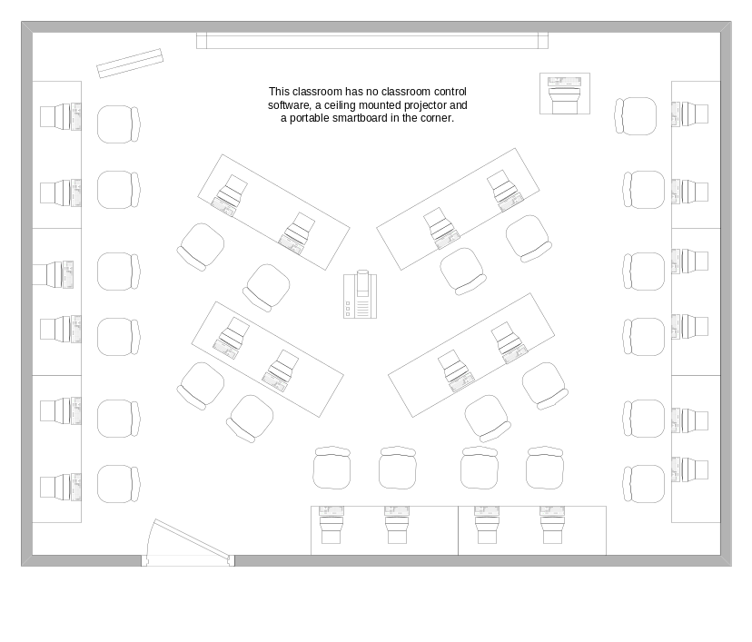
Setting: 50-minute session for a science or engineering class; students have a course assignment requiring research. The librarian uses the course assignment to create a sample topic for the library session.

With very little introduction from the librarian, students are asked to work in groups of two or three to conduct a sample topic search in one of 2 or 3 recommended databases. They are told their small group will be reporting out to the whole group about their search strategy once they have found a relevant article citation. Students are given 10-15 minutes to search, during which the librarian circulates around the room to observe and answer questions.

Since students are just jumping in, they’ll make mistakes and may have questions for the librarian. Once all groups are finished, the librarian asks representatives for each of the 2-3 databases to report out about their search. One representative group for each is all there may be time for. Students will come to the instructor’s station to demonstrate their search. The class uses this time to ask questions and the librarian can clarify what’s being demonstrated. As students representing different databases report, the librarian will ask the group to identify differences in their functionality and in the citations identified as relevant.

Depending on the librarian’s relationship with the course instructor, students may be asked to conduct additional sample searches in recommended databases on their own as a follow-up and hand in this work to the librarian.

~ Facilitator: Melanie Remy, University of Southern California

Brown Table

Standard 2, Performance Indicator 2.

Outcome:
- Constructs a search strategy using appropriate commands for the information retrieval system selected (e.g., Boolean operators, truncation, and proximity for search engines; internal organizers such as indexes for books).

Floor Plan

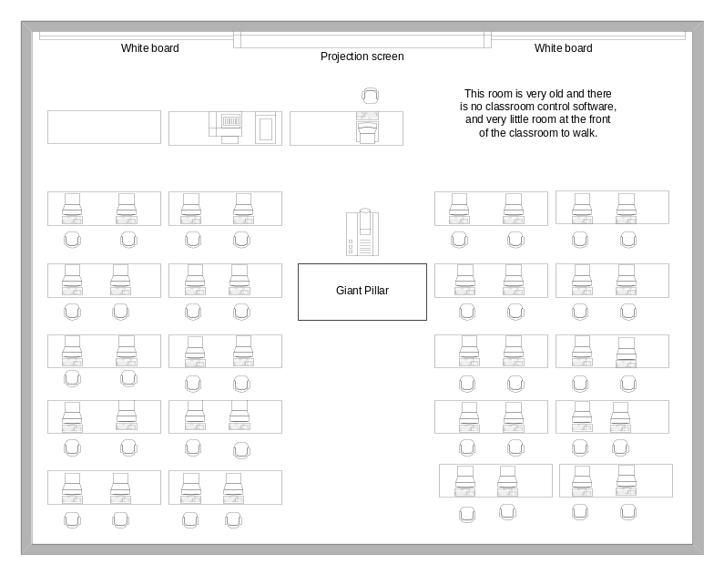

We’re teaching a 50-minute class to first-year second-semester students in a research/composition class; students do not have topics yet, but the general topic focus is current events.

Specific class focus: Students will learn to search in an article database which has broad general coverage and some full text.

Preparation: Select 6 current events topics, one to use in teaching example, 5 for students to use in hands-on practice.

Demonstration & class discussion: Because the “giant column” in the middle of the room makes it difficult for everyone to see, the teacher will ask for 2 volunteers to write everything on the 2 whiteboards at the front of the room during the opening discussion and search demonstration.

Using the example current events topic, the teacher will ask class members to identify
- keywords
- synonyms

The teacher will talk about use of AND and OR to combine the keywords and synonyms in creating database search statements. Teacher will demonstrate various searches in the chosen database using the example topic, asking for student suggestions about how to modify the search statement.

Hands-on activity: Students will work in groups. Each group will include the students sitting in one row on one side of the room. Classroom seating allows for 10 groups of 4 students. Each hands-on topic will be given to 2 different groups. They will be asked to identify keywords and synonyms and to use those terms to create search statements. Groups will have an opportunity to try out their searches for the class on the instructor’s station. Groups will report back to the whole class, comparing the terms identified, search statements created, and search results.

~ Facilitator: Gale Burrow, Libraries of the Claremont Colleges

Blue Table

Standard 2, Performance Indicator 3

Outcome:
- Uses various search systems to retrieve information in a variety of formats.

Floor Plan

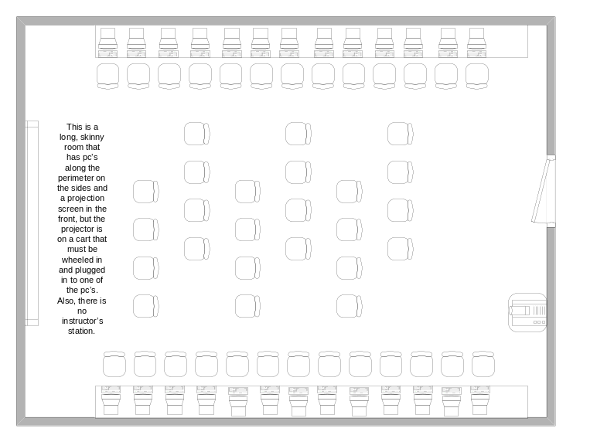

Assumptions made by our group: This will be a 50-minute session with 20 Freshmen or first-year English composition students. The librarian has already met with these students once before to work on their individual topics, teach them how to develop synonyms and search strategies. The librarian knows the students’ topics already.

In this second session, the librarian will demonstrate developing a search strategy. Next, s/he will create 4 groups of five students. One general topic will be given to all the groups (and this will not be a topic that any of the students has chosen). All the groups will search using this same topic but using different search tools as assigned (online catalog, two databases, web). Each group will report what they found using the overhead projector. Students can then compare the results found using these different search tools.

~ Facilitator: Deb Moore, Glendale Community College

Pink Table

Standard 2, Performance Indicator 3

Outcome:
- Uses various search systems to retrieve information in a variety of formats.

Floor Plan

Audience: Upper level undergraduate course in any subject area that prepares students for some type of senior project or capstone experience.

Duration of Library Instruction: 1 hour

Activity: Compare common elements across databases/catalogs, e.g. scope, fields, results, etc.

For a class with 24 students or less: students would work in pairs. Each student searches a different database/catalog (search tools). Then, the students compare their results. They are able to view both tools at the same time, with one tool displayed on each of the students’ monitors. The middle workstation in each row of 5 would remain open. Pairs of students would use workstations 1, 2, 4, and 5 in each row.

For a class with over 24 students: students would work in groups of 2 or 3. Each student searches a different database/catalog (search tools). Then, the students compare their results. They are able to view the search tools at the same time, with one tool displayed on each of the students’ monitors.

Students could use the classroom control software to report their findings to the rest of the class. The overhead is pretty useless since the students’ backs are facing it.

~ Facilitator: Katy Farrell, University of California – San Diego

